TEMPLATES

1. EMPATHY MAP

2. BRAINSTROMING MAP

3. DOWNLOAD TABLEAU

4. DOWNLOAD DATASETS

5. CONNECTED DATASETS

6. CREATE DATA VISULIATIONS

7. CREATE DASHBOARD

8. CREATE STORY

9. PUBLISH DASHBOARD AND STORY

10. CREATE PROJECT REPORT

11. CREATE DEMO VIDEO

1. EMPATHY MAP

First I create a empathy map. This empathy map is about say, think, does, feel. I told that in say place the agriculture plays vital role in India. In the think place I told what is the advantages of agriculture. In the does place I told how to develop the agriculture.

1. BRAINSTROMING MAP First I found the problem of Indian agriculture and discuss our problem and find solution ideas .Next I collect the solution ideas and add the brainstorming map.
2. DOWNLOAD TABLEAU

Tableau provides three versions of Tableau Desktop [4]. The Public version is free but the Personal and Professional versions are available with a fee or free 14-day trial. However, Tableau provides a 1-year free product key with support for students and instructors in academic programs. Tableau provides three versions of Tableau Desktop [4]. The Public version is free but the Personal and Professional versions are available with a fee or free 14-day trial. However, Tableau provides a 1-year free product key with support for students and instructors in academic programs.

1. DOWNLOAD DATASETS

I download datasets using the link https://www.kaggle.com/datasets/pyatakov/india-agriculture-crop-production

DATA CHARACTERSTICS Data consists of 345409 rows and 10 columns that correspond to different values.

Column Description of the Dataset:

State : The name of the Indian states

. District : The name of the districts of Indian states.

Crop : Name of different crops grown in India

Year : Date Season : India has 5 seasons for crop cultivation: kharif, rabi, autumn, winter and summer.

Area: Area for crop cultivation in acres

Production : Production of crops in tones

Yield : Yield by the crops under cultivation

5. CONNECTED DATASETS

I connected my datasets in tableau using the explanation video https://drive.google.com/file/d/1lFkX-rmppN_Z9-R5fTj5RoEpUqF4_eJl/view?usp=sharing

6.CREATE VISUALIZATION

I Create the data visualization sheets : State wise Agricultural Land , : Area vs Production , Season based cultivation , Yield by season , Crop plantation by area , Major crops growth Yoy , Crops , Season wise production , : Kpi’s sheets .

7. CREATE DASHBOARD

I Create dashboards using the data visualization sheet

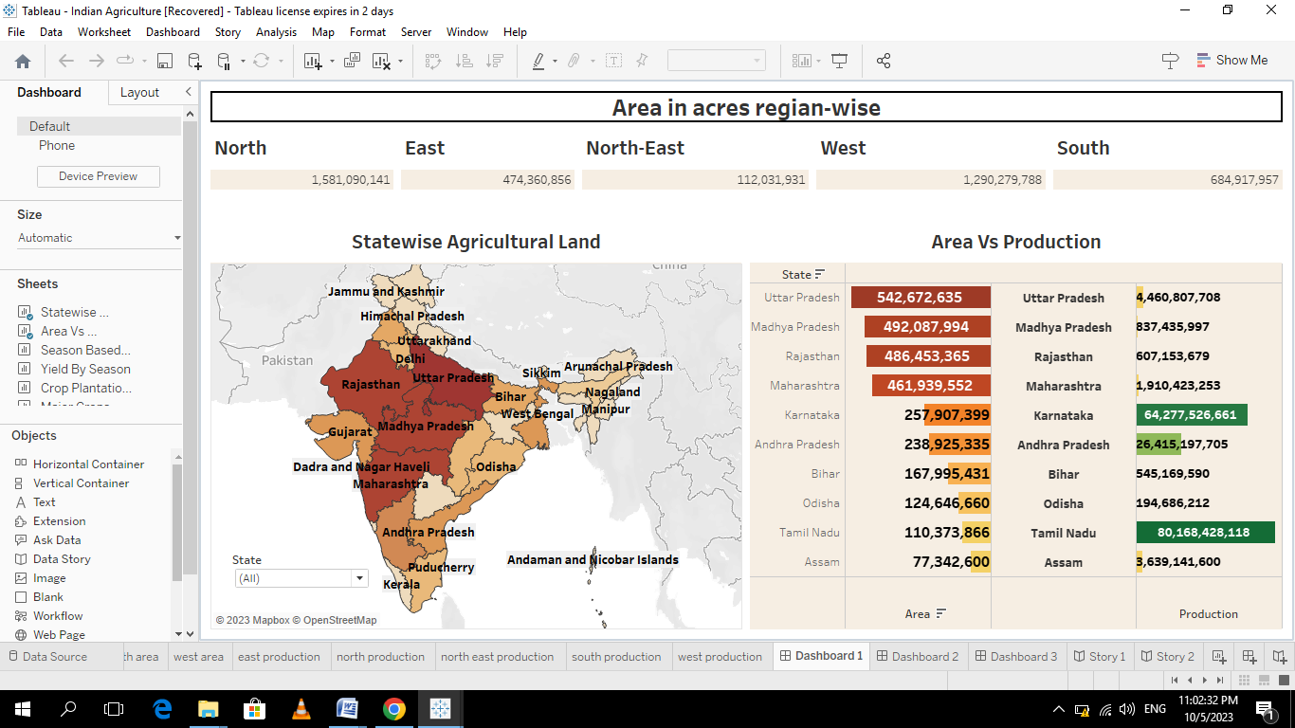

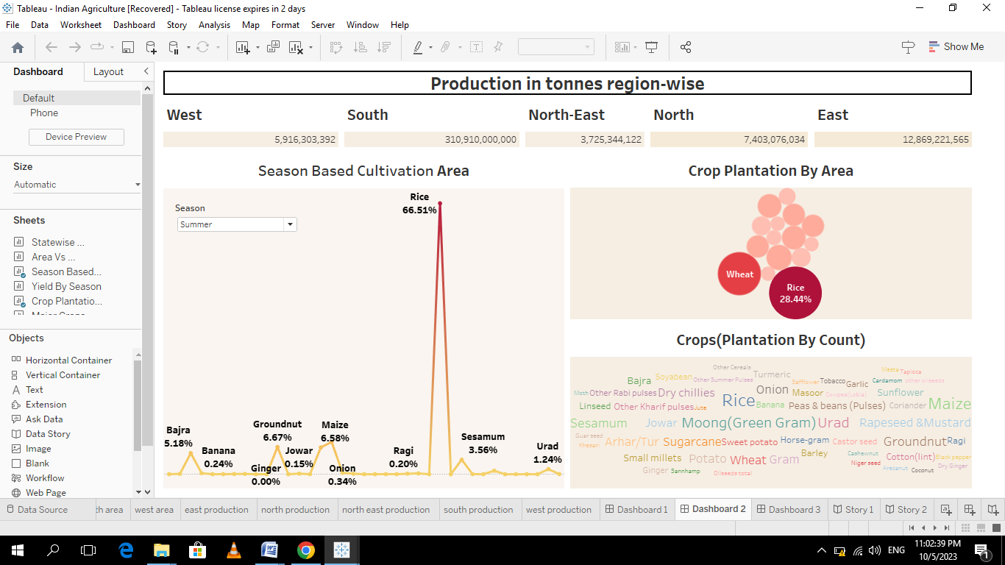

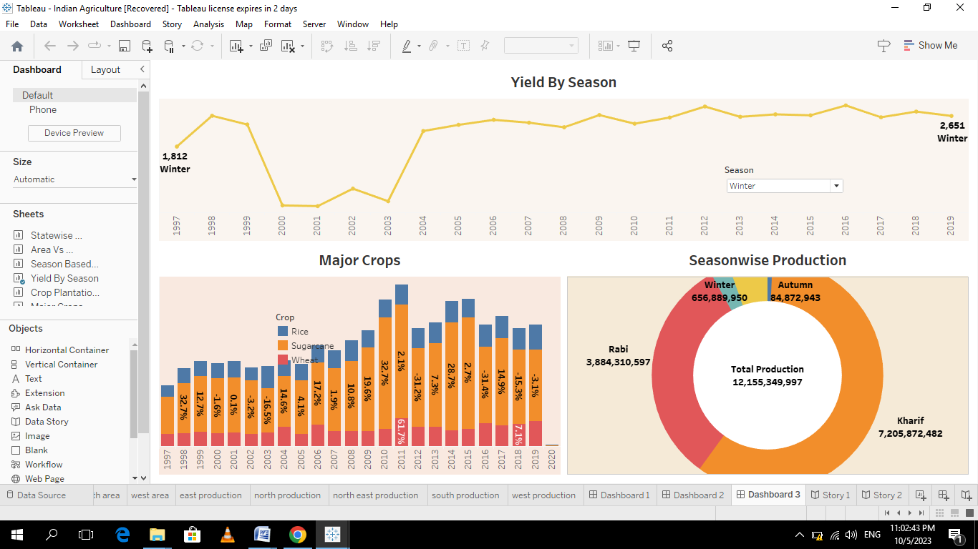8.CREATE STORY

I create story using data visualization sheets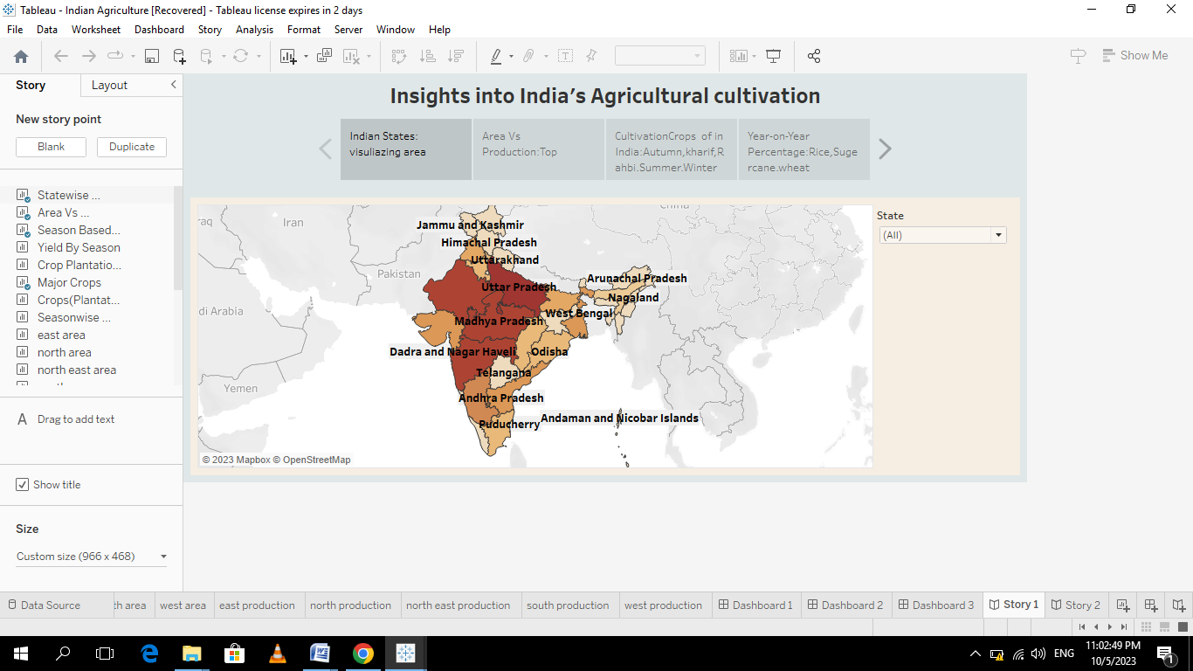

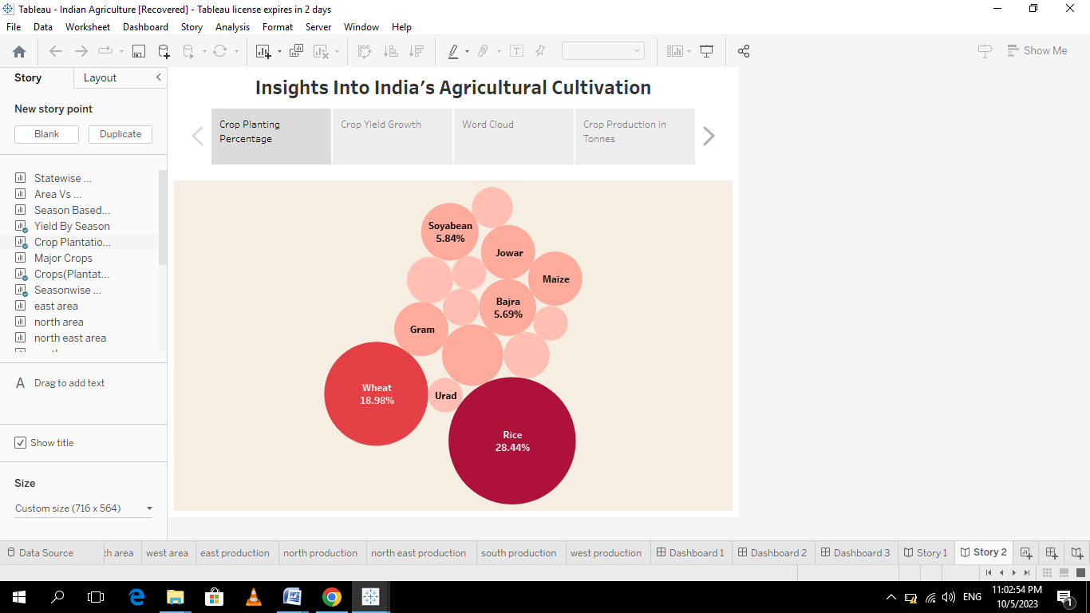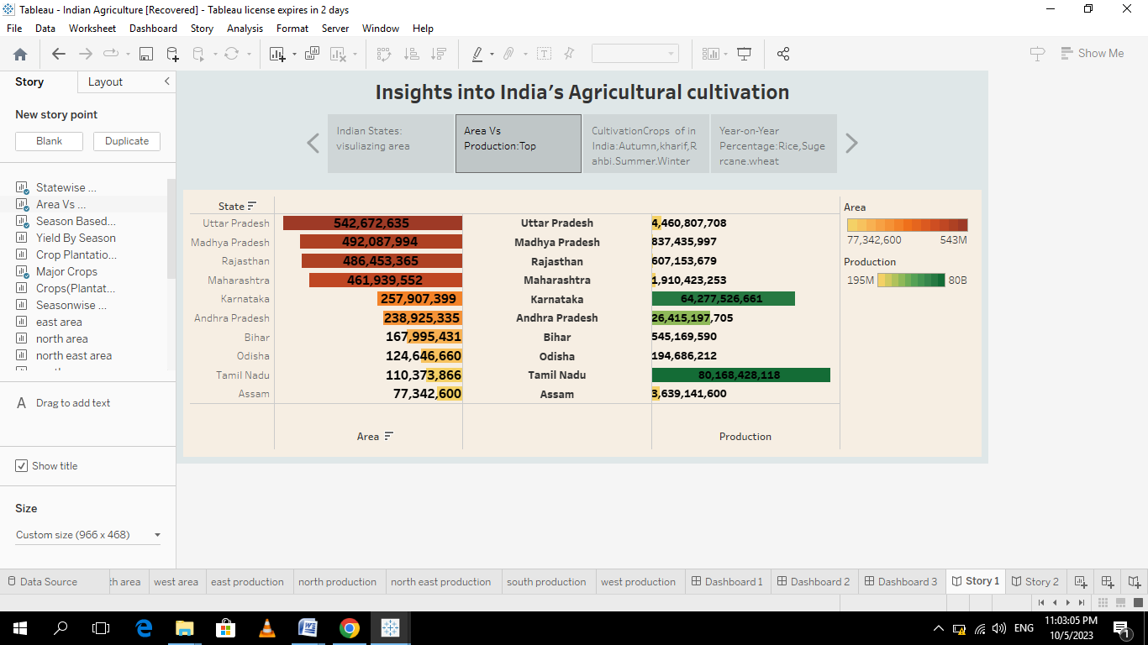

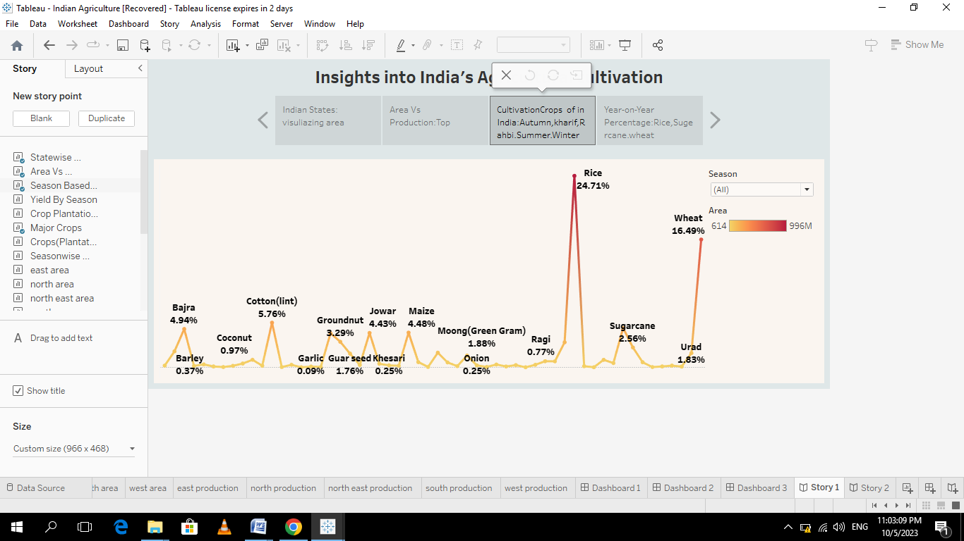

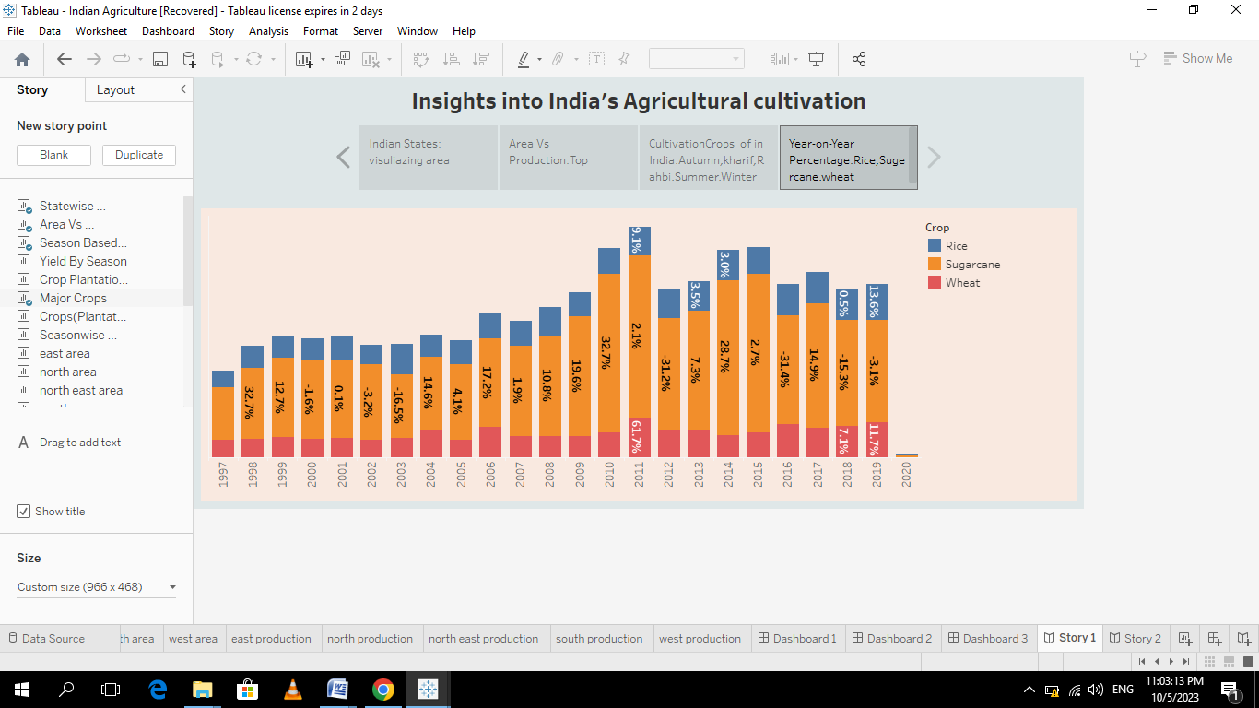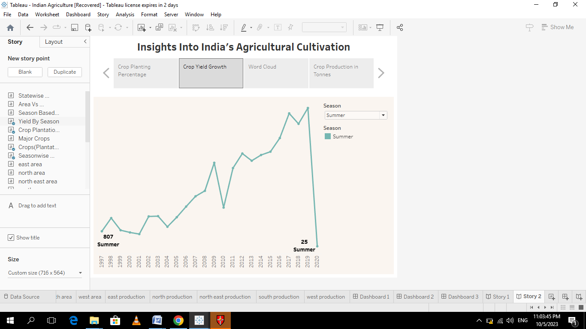

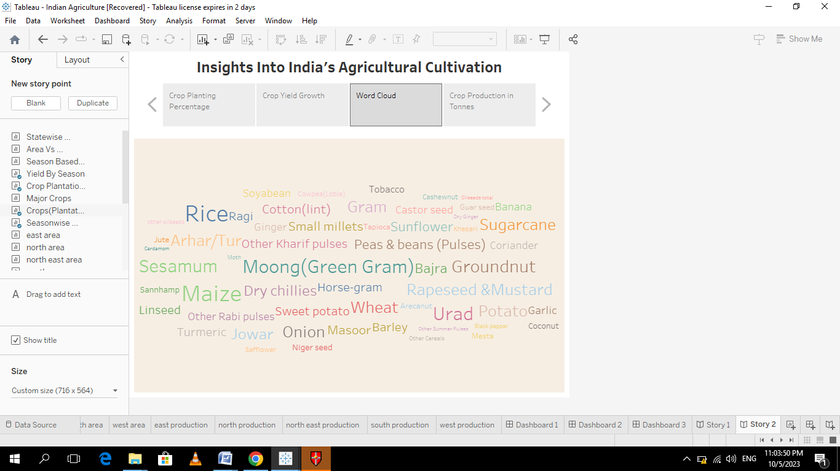

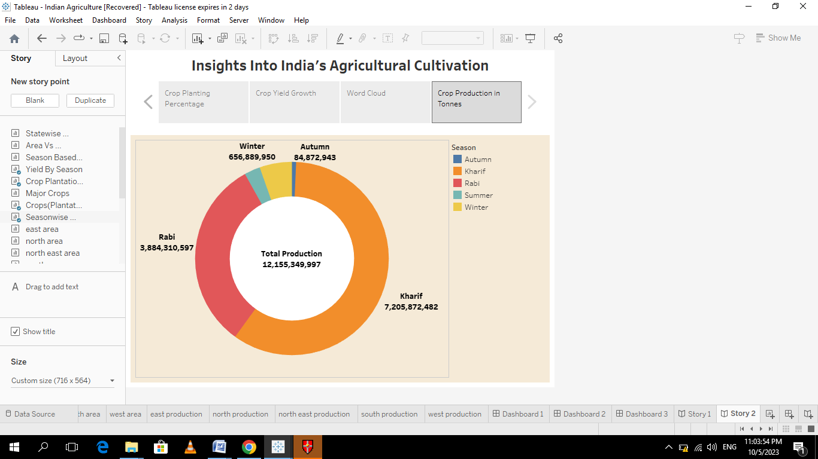

9.PUBLISH DASHBOARDS AND STORYS

The number of scenes in a storyboard for a data visualization analysis of the performance of banks will depend on the complexity of the analysis and the specific insights that are trying to be conveyed. A storyboard is a visual representation of the data analysis process and it breaks down the analysis into a series of steps or scenes.

Using the explanation videohttps://drive.google.com/file/d/1cRl1bedHnSNtKPzyL_1LODCuaLptKjDE/view?usp=sharing

10. PROJECT REPORT

I create my project report step-by-step project process

11.PROJECT DEMO VIDEO

I record project demo video step-by-step project processI

TEMPLATES

1.EMPATHY MAP

2.BRAINSTROMING MAP

3.DOWNLOADE TABLEAU

4.DOWNLOADE DATASETS

5.CONNECTED DATASETS

6.CREATE DATA VISULIATIONS

7.CREATE DASHBOARD

8.CREATE STORY

9.PUBLISH DASHBOARD AND STORY

10.CREATE PROJECT REPORT

11.CREATE DEMO VIDEO